**Skyline Batch**  
  
Skyline Batch is a user-friendly tool to run a simple Skyline workflow on many files at a time. When run, it uses an invisible instance of Skyline to do the following:

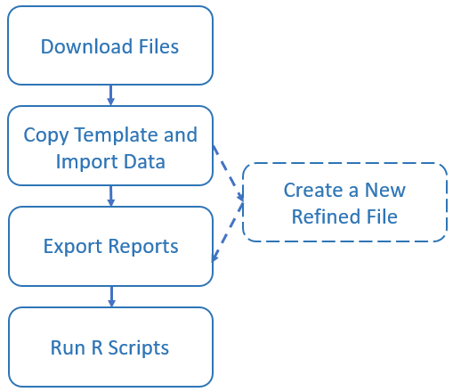

**Download Files**: If any of the files used during the Skyline Batch run are located on a server, Skyline Batch will check if they exist on disk. If they are missing, they are downloaded during this step.

**Copy Template and Import data**: This step uses a Skyline template file to create a new Skyline results file. First, the template is copied to a specified “analysis” folder, then data is imported into it. Since the template is copied into a new folder first, the original Skyline template file is not changed and can be used for many different Skyline Batch runs.

**Create a New Refined File**: This step is only executed if refinement settings are specified (to learn more about adding refinement settings, see the documentation for the **Refine** tab in the **Skyline Batch Configuration** form on page 7). The refinement will be done using the Skyline results file generated in the previous step, then saved as a new file in a specified location. Creating the refined file in this step does not change the Skyline results file or the Skyline template file.

**Export reports**: Reports are CSV files containing useful information about the data in a Skyline file. They can be created from either the results file or the refined file (if it exists). Configurations do not need to export any reports (although this is necessary if you want to run R scripts). If the configuration has no reports, the Skyline Batch run will finish after the previous step.

**Run R Scripts**: R scripts are run using the exported reports from the previous step. Each R script receives the data from a specific exported report as input. Running R scripts is not required, you can export reports without running any R scripts on it.

**STARTUP**  
  
Skyline Batch requires an installation of Skyline (or Skyline-Daily).

On startup, you will see the main window:

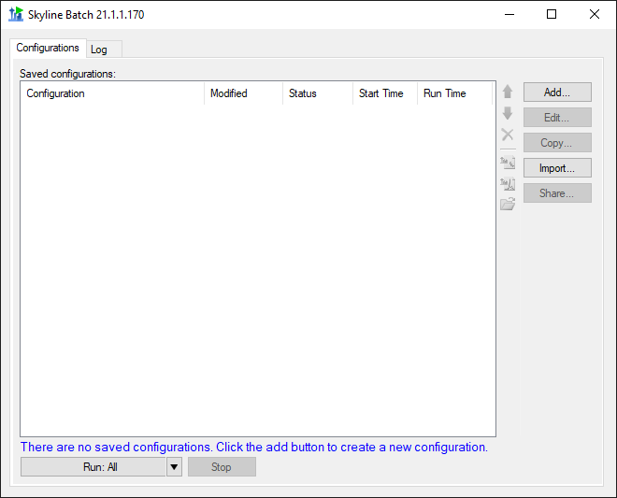

To start using Skyline Batch, create a new configuration by clicking the **Add** button.

This brings up the **Skyline Batch Configuration** form.

**CONFIGURATION Files**

In the **Skyline Batch Configuration** form enter the appropriate settings in the **Files** tab.

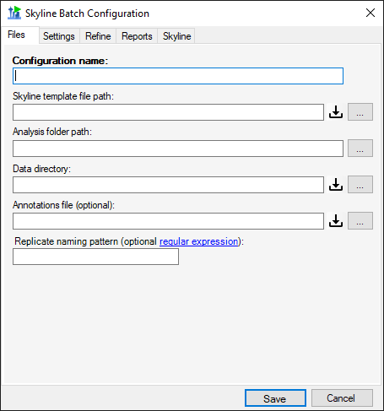

**Configuration name**: This can be the name of the project or study for which data is being acquired. The configuration name must be unique.

**Skyline template file path**: This is the path to the template Skyline document that will be copied to the analysis folder and used to import data into.

If you have other configurations that create refined template files, an arrow will appear on the right side of the template file input, allowing you to either select from these files or choose your own template with the download and browse buttons.



*Note: For Skyline Batch to find the assay library, the Skyline template file location must be in the parent hierarchy of the analysis folder. (ie: If my Analysis folder is “C:\Users\myaccount\Documents\Analysis”, then my template file must be in “users,” “myaccount,” or “Documents”). This does not apply to refined templates.

**Analysis folder path**: The path to the local folder in which the copied template document and exported reports will be stored.

**Data directory**: The folder containing data to import into the copied template document. This folder should never contain anything aside from the data files you wish to import.

**Annotations file**: An optional CSV file containing the annotations for the imported data.

**Replicate naming pattern**: An optional regular expression from which the first group will be used to name replicates when importing.

**Downloading Files**

This button indicates that the file can be downloaded from a remote server. Its color indicates if a remote server was added, and if the file will be downloaded:



 No server – the file already exists on the computer.

 Server – the file will be downloaded to the specified file path.

For example



The blue server button indicates that QEP_2015_0424_RJ.sky will be downloaded from a server. The Skyline template file path indicates that the downloaded file will be placed in the “D:\Users\alimarsh\PasswordTest\” folder.

**Downloading Data Files**



The download button next to Data directory opens the **Download Remote Data Files** dialog:

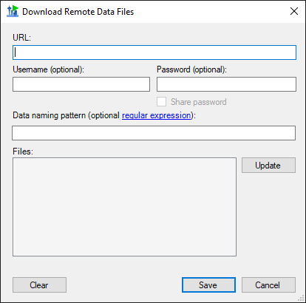

The **Download Remote Data Files** dialog is unique as it allows you to download a set of files from a server, whereas the other download file dialogs will download a single file.

**URL**: The URL to the data folder on a Panorama or FTP server.

**Username**: The username for the server if it has one.

**Password**: The password to the server if it has one.

**Share Password**: If the password should be sharable between computers (stored and saved in plain text instead of being encrypted). This is only recommended for publicly available passwords that you wish to share between computers in a Skyline Batch Configuration file.

**Data naming pattern** (optional): A regular expression that matches the names of the desired data files on the server.

**Files**: This is a list of the files at the URL that will be downloaded. When the URL, Username, or Password are changed, this list can be updated by clicking the **Update** button. The file list updates automatically if only the regular expression is changed.

An updated files list looks like this:

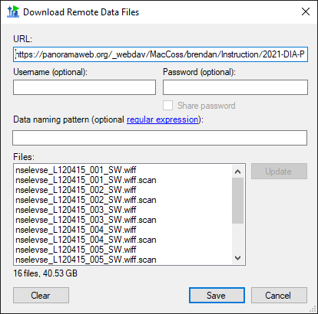

The data server can be removed with the **Clear** button.

**Downloading Panorama Files**

All other download buttons bring up the similar **Download File From Panorama** dialog:

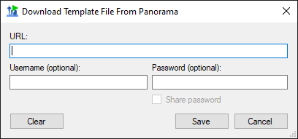

This will download one file at the specified URL.

**URL**: The LabKey URL to the file on a Panorama server (must have “_webdav” in the URL).

**Username**: The Panorama username if it is required to access the file. Note that Panorama usernames are complete email addresses.

**Password**: The Panorama password if it is required to access the file.

**Share Password**: If the password should be sharable between computers (stored and saved in plain text instead of being encrypted). This is only recommended for publicly available passwords that you wish to share between computers in a Skyline Batch Configuration file.

**CONFIGURATION Settings**

In the **Settings** tab, various changes to the Skyline document can be specified.

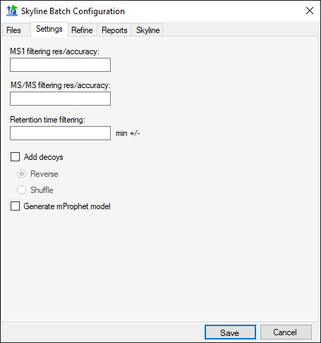

**MS1 filtering res/accuracy** (optional): Resolving power of the precursor mass analyzer. If the mass analyzer is 'Centroided' the value is in PPM.

**MS/MS filtering res/accuracy** (optional): Resolving power of the product mass analyzer. If the mass analyzer is 'Centroided' the value is in PPM.

**Retention time filtering** (optional): The number of minutes on either side of the predicted time or MS/MS IDs, i.e. ± minutes.

**Add decoys**: Add decoys to the template document for reintegrate model generation with mProphet. Added decoys are shuffled or reversed based on selection.

**Generate mProphet model**: causes a new model to be created, using the mProphet algorithm with all available scores for the results found in the document. Existing manually integrated peaks will be overwritten with peaks chosen by the reintegration model.

**Configuration refine**

In the **Refine** tab, a new refined Skyline file can be created using the imported data.

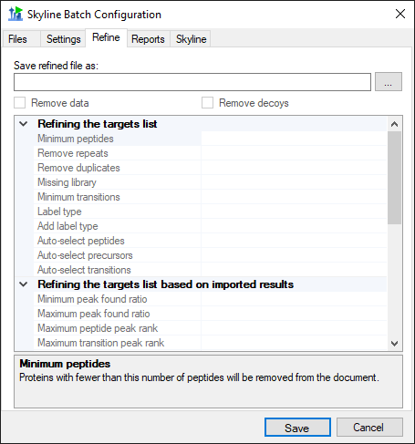

**Save refined file as**: The file path for the new refined file. This is required for any refinement to occur, and the rest of the **Refine** tab will be disabled until this field is filled.

*Note: All the refine commands are performed on the refined file and will not change the results file in the analysis folder.

**Remove data**: If data should be removed from the refined file.

**Remove decoys**: If decoys should be removed from the refined file.

The descriptions for each of the commands in the grid can be found by clicking on the name of the command.

To enter a value for a command, click on the empty space next to its name. A list of options will appear, or you can type other input.

**CONFIGURATION REPORTS**

In the **Reports** tab, a list of reports can be created. If no reports are included for a configuration, Skyline Batch will not export reports or run R scripts for that configuration.

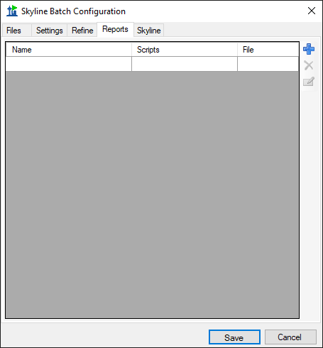

To add a report, click the blue **+** icon on the right and fill in the appropriate information.

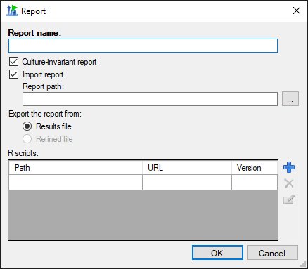

**Report name**: The name of the report to be exported. This MUST correspond to the name of the report when used in Skyline, which may differ from the file name. To find the name of a report:

If you are importing the report from a Skyline report file (.skyr), open the file in Notepad and look for: *name="*report name here"

If you are using a report already imported in your Skyline template document,

open the document and go to View > Document Grid > Reports to see a list of all the report names.

**Culture-Invariant report**: If the report should use comma separated values with period decimal points. It is recommended you always use a Culture-Invariant report if you plan to run R scripts on the report.

**Import report**: If the report does not exist in your Skyline template document, and needs to be imported from a Skyline report file.

**Report path**: The path to the Skyline report file.

**Export the report from**: Whether to export this report from the results file or the refined file. The refined file option will be grayed out if this configuration does not do refinement (ie: no file path was provided in the **Save refined file as** input on the **Refine** tab).

**R scripts**: The list of R scripts to run on this report after it has been exported to a csv file.

Add an R script by clicking on the blue **+** icon.

**R Scripts**

The blue **+** icon brings up the **R Script** dialog:

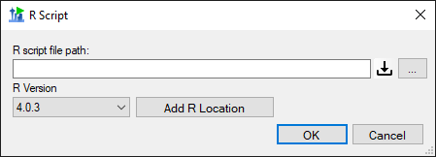

**R script file path**: The path to the R script.

**R Version**: The version of R that will be used to run this R script. The version of R can be changed in the drop-down list, or additional versions can be added to the list with the **Add R Location** button.

The download button indicates that this file can be downloaded from a server. Information about the **Download File From Panorama** dialog that appears when this button is clicked can be found on page 6.

**SKYLINE SETTINGS**

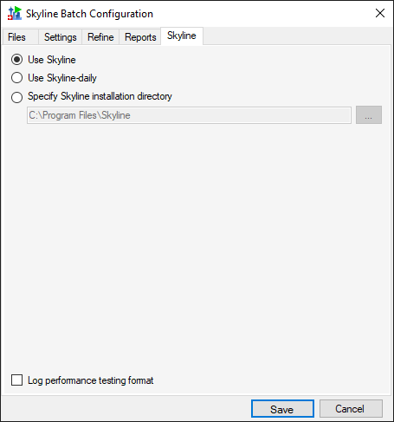

In the **Skyline** tab of the **Skyline Batch Configuration** form, you can specify which installation of Skyline this configuration will use when run. If you do not have an administrative or web-based installation of Skyline or Skyline-daily, the corresponding option will be grayed out. You can always specify a path to a Skyline (or Skyline-daily) installation somewhere else on your computer.

**Log performance testing format**: This controls whether or not the log for this configuration will be generated in a performance testing format. This format uses 24 hour time, is tab-spaced, and adds memory stamps to the output on the log tab. Unless you plan to analyze memory usage of the Skyline operations performed by the configuration, it is reccommended you leave this unchecked.

*Note: The Skyline tab does not appear in administrative installations of Skyline Batch. These installations use the version of Skyline they were installed with. If you have an administrative installation and want to change the Skyline Settings in this tab, download the web-based version of Skyline Batch here: <https://skyline.gs.washington.edu/software/SkylineBatch/index.html>

**SHARING CONFIGURATIONS**

To save some or all of your existing configurations to a Skyline Batch configuration file (.bcfg), click the **Share…** button in the main window.

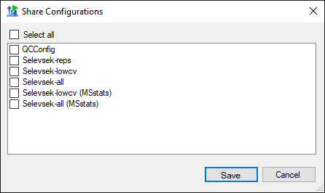

In the Share Configurations Form, you can select configurations you wish to save. Then click **Save**. Skyline Batch will then prompt you for a file location to save the configurations.

*Note: Skyline Batch can do better file location on new computers if the configuration is saved close to its files. This will result in fewer invalid configurations that need manual fixing. If you plan to share configurations across computers, it is recommended you save the configuration file in the same folder as one of the Skyline template files.

The configurations in the resulting file can be imported using the **Import…**  button, or by double-clicking on a Skyline Batch configuration file in File Explorer.

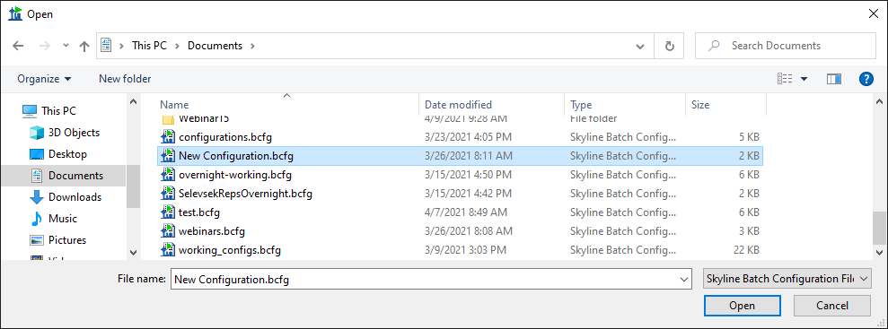

**INVALID CONFIGURATIONS**

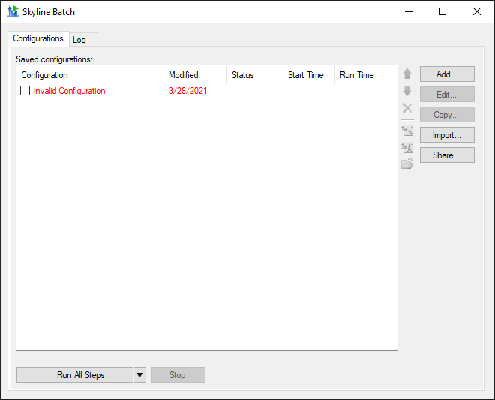

Invalid configurations may occur if files in the configuration do not exist, the configuration downloads files and could not reach the server, the configuration uses a version of R not found on your computer, or the Skyline version was not found. They will appear in red, and cannot be run until they have been corrected. When you **Edit** an invalid configuration, the **Configuration Set Up Manager** will guide you through the process of fixing it.

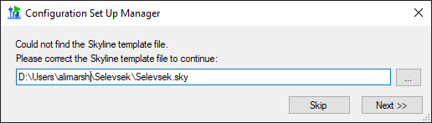

**RUNNING CONFIGURATIONS**

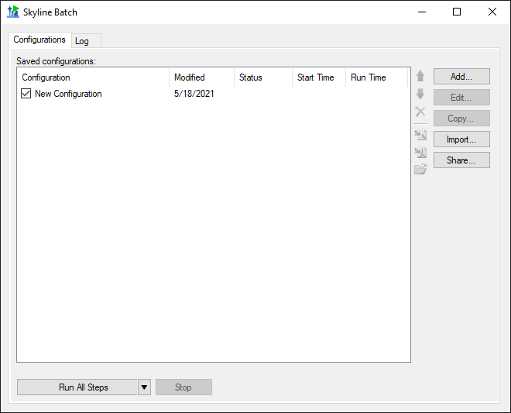

To run a configuration, check the checkbox next to it, then click the **Run All Steps** button.

The **Run All Steps** button will run every checkedconfiguration in the list from top to bottom. The downward-facing triangle on the righthand side of the **Run All Steps** button enables the user to start from a later step when running the configurations.

The **Run from step** options depend on the configurations checked:

At least one configuration with a **refined** No configurations with a **refined output**

**output file** is checked: **file** are checked:

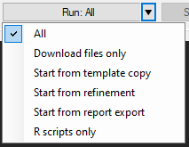 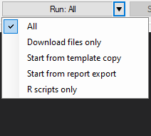

Each option runs the following section of the Skyline Batch workflow:

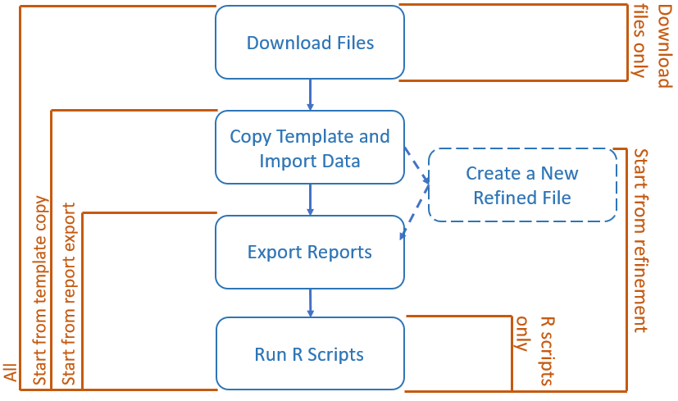

Keep in mind that a configuration without missing files, refinement, reports to export, or R scripts will skip the corresponding steps.

When the **Run All Steps** button or a **Run from step** option is clicked, the program switches to the **Log** tab to display the progress of the current run. Returning to the **Configurations** tab, the status of all configurations is displayed, and will show if they are Running, Waiting, Finished, Canceled, or had an Error. Stop the configurations from running by clicking the **Stop** button. If any configurations are running when Skyline Batch is closed, they will be canceled.

**LOGGING**

This is the view of the **Log** tab after the configurations have started running.

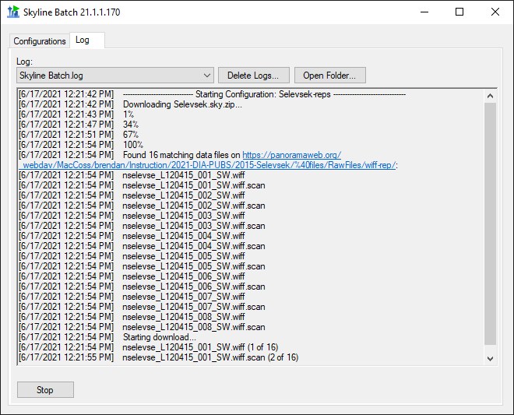

The log will display all output from running the configurations, including which configuration is currently running, what step it is on, and the progress of that step.

Logs of previous runs can be viewed by clicking the **Log** dropdown menu. Previous logs can be managed with the **Delete Logs** button and the folder containing the saved logs can be opened with the **Open Folder** button.

**ACCESSING RESULTS**

A configuration has finished running when its status no longer says “Running” and a Run Time is shown.

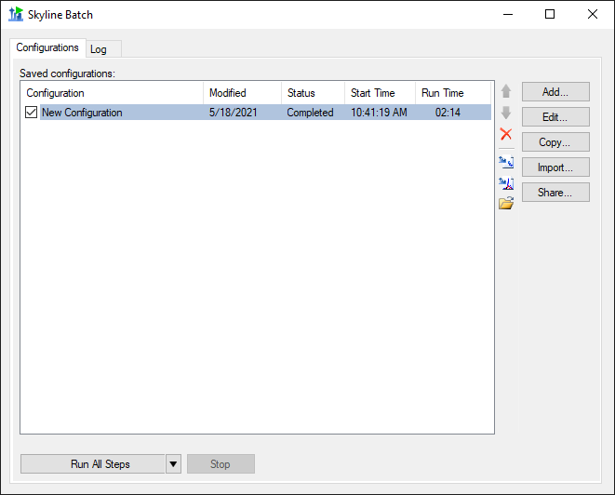

To view the results and associated files, select the configuration and click one of these icons:

Opens the Skyline template document



 Opens the Skyline results document

 Opens the analysis folder